Alternate Assignment-4

# Learning Objectives

* Deep Learning
* Computer Vision – Convolutional Neural Network
* Hands-on hardware real-world integration – Google AIY Vision Kit

# Introduction

* AIY – Artificial Intelligence Yourself – Google’s do-it-yourself Artificial Intelligence kit
  + With the maker kits, build intelligent systems that see, speak, and understand. Then start tinkering. Take things apart, make things better. See what problems you can solve.
  + <https://aiyprojects.withgoogle.com/>
* AIY Vision Kit
  + Do-it-yourself intelligent camera. Experiment with image recognition using neural networks.
  + The AIY Vision Kit from Google lets you build your own intelligent camera that can see and recognize objects using machine learning. All of this fits in a handy little cardboard cube, powered by a Raspberry Pi.
  + <https://aiyprojects.withgoogle.com/vision/>

# Meet Your Kit

* <https://aiyprojects.withgoogle.com/vision/#meet-your-kit>
* Unopened box  
  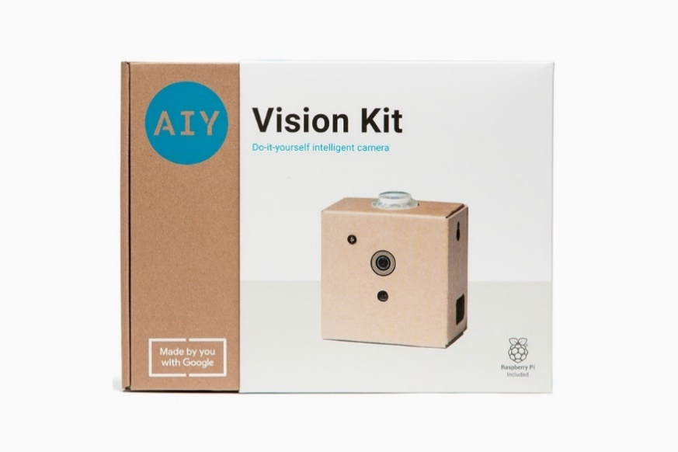
* Built Kit  
  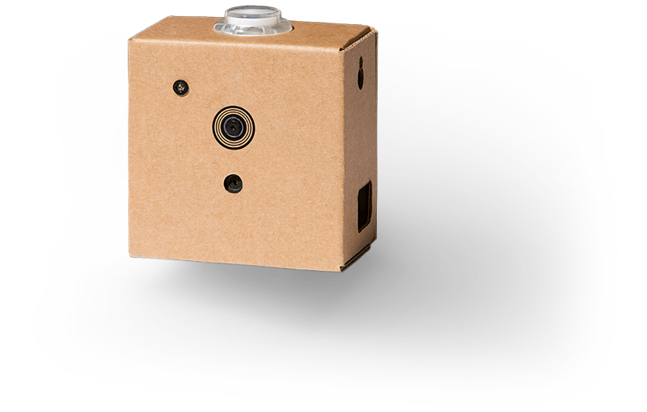

## Materials Provided

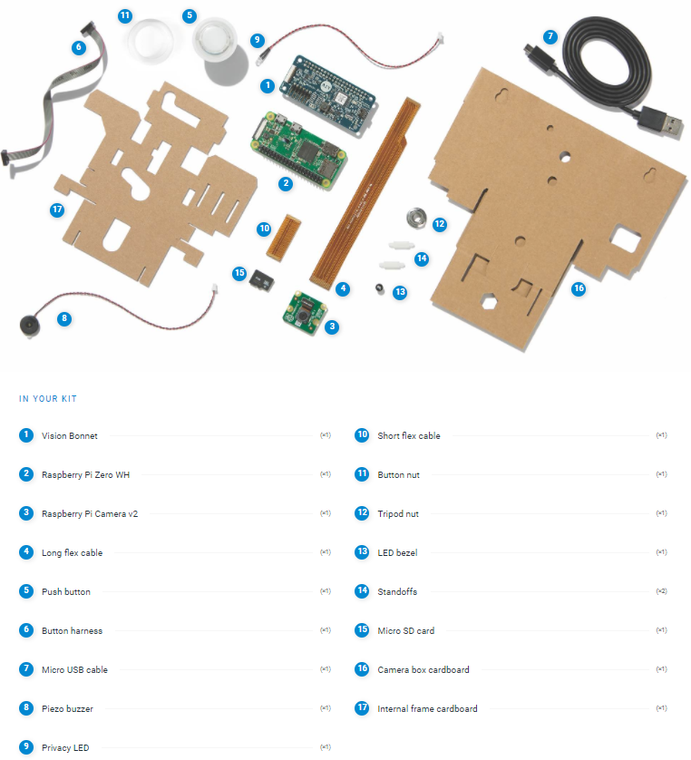

## Materials NEEDED

* <https://aiyprojects.withgoogle.com/vision/#meet-your-kit--gather-additional-items>
  1. OPTION-1 – using the AIY projects app.
     + Computer – Windows, Mac, Linux
     + Android smartphone
     + Wi-Fi connection

Following is the approach outline for this project using this option:

* + - Connect the kit to computer using Wi-Fi and Android smartphone.
    - Code on your computer and load the trained model on kit using the connection.
    - Run the program on the kit to see only command line output but no visual output (e.g., imshow()).
  1. OPTION-2 – using external monitor, mouse, and keyboard.
     + Computer – Windows, Mac, Linux
     + Mouse, Keyboard + Micro USB Hub
     + Monitor/TV with HDMI input + HDMI (monitor) to mini-HDMI (kit) adapter

Following is the approach outline for this project using this option:

* + - Connect the kit to the external monitor, mouse, and keyboard to use it as a separate computer.
    - Code either on your personal computer or directly on the kit.
    - Run the program on the kit to see both visual (e.g., imshow()) as well as command line output.
* (Optional) MicroSD card connecter
  + <https://aiyprojects.withgoogle.com/vision/#assembly-guide--get-the-latest-system-image>
  + Connect the card to your computer to obtain the latest system image.
  + It will work fine even if you use the old system image and SDK, except that some pre-built programs and corresponding functions may not work as expected, and you would need to refer to the old docs.

# Assignment Tasks

## Build Your Kit (40 points)

* <https://aiyprojects.withgoogle.com/vision/#assembly-guide>
* Go through the instructions provided on the above website and build the kit.
* You can ignore the “Get Latest System Image” section mentioned on the website (<https://aiyprojects.withgoogle.com/vision/#assembly-guide--get-the-latest-system-image>), if you do not have a MicroSD card connector – referred as optional in the “materials needed” section above.

## Try It Out (20 points)

* <https://aiyprojects.withgoogle.com/vision/#try-out>
* Once the kit is built, turn it on and use “Joy Detector” – the default application that has already been loaded onto the SD card.
* As mentioned in the instruction, at any point while Joy Detector is running, you can snap a photo by pressing the button.
* If you take a photo while the camera detects a face (the button is illuminated), it saves a second version of the photo that's annotated with the joy score.
* These photos are saved on the SD card in the ~/Pictures/ directory.
* To get all the points for this task, you need to save 3-5 photos with different joy scores.

## Deploy Pre-Loaded Demos (40 points)

* Depending on the materials you have, pick one of the two options mentioned above in “Materials Needed” section.
* Connect to your kit using the selected option by following the instructions mentioned here – <https://aiyprojects.withgoogle.com/vision/#connect>
* Once connected, stop the “Joy Detector” demo, and explore other demos – <https://aiyprojects.withgoogle.com/vision/#try-more-demos>
* Specifically, you need to work with the following demos:

1. Taking a photo using Raspistill – <https://aiyprojects.withgoogle.com/vision/#try-more-demos--take-a-photo-using-raspistill>
2. Image classification on an image – <https://aiyprojects.withgoogle.com/vision/#try-more-demos--try-image-classification-on-an-image>
   * 1. Use the (0) demo to take 3-5 photos of different objects (can be any object include humans and animals) using the camera.
     2. Run the image classification demo on these images and save the results.
3. Object detection on an image – <https://aiyprojects.withgoogle.com/vision/#try-more-demos--try-object-detection-on-an-image>
   * 1. Use the (0) demo to take 3-5 photos of cat, dog, or person using the camera.
     2. Run the object detection demo on these images and save the results.

## Design & Deploy New Computer Vision Demo (50 points)

* Decide any computer vision application of your choice.
* Find the dataset to be used for training.
* Create a TensorFlow model. Look at the following examples:
  + <https://aiyprojects.withgoogle.com/vision/#retrain-a-classification-model>
  + <https://colab.research.google.com/github/google/aiyprojects-raspbian/blob/aiyprojects/tutorials/vision/aiy_retrain_classification.ipynb>
* TensorFlow CONSTRAINTS for the Vision Bonnet compiler:
  + <https://aiyprojects.withgoogle.com/vision/#constraints>
* To deploy the model on the kit, you need to use the Vision Bonnet compiler to convert the model file into binary file that’s compatible with the Vision Bonnet.
  + <https://aiyprojects.withgoogle.com/vision/#vision-bonnet-compiler>
* Download the compiled model.
* Copy the files to the Raspberry Pi.
* Run the model on the Vision Kit to make the demo work with live data from the camera.

## Extra Credit – Innovation & Performance (10 points)

* Extra credit points will be awarded by considering the innovation aspect of the computer vision application selected as well as based on the performance of the model.

# Assignment Timeline

* 07/15 – assignment released.
* 07/18 – last date to sign-up for the alternate assignment.
* 07/22 – last date to collect the kit from the instructor’s office.
  + Work with the instructor on the times to collect the kit.
  + NEED to sign the removal of equipment form.
* 08/08 – last date to submit the code and report for the assignment.
* 08/12 – last date to return the kit.
  + NEED to show a live working demo of the application.
  + Work with the instructor on the times to show demo and return the kit.

# Submission Instructions

* Complete all the tasks above.
* Create a report for the assignment and include the following (as required):
  + Screenshots of the command line of the Raspberry Pi for the demos.
  + Video recording of the demos from your phone (if needed).
* Submit the report and any media links on Blackboard.
* Show a live demo of the application to the instructor.
* Return the kit.
  + You will not get any grades if the kit is not returned.
  + You will be required to reimburse for the loss of the kit.

## Rubrics

* (40 points) Build Your Kit
* (20 points) Try It Out
* (40 points) Deploy Pre-Loaded Demos
* (50 points) Design & Deploy New Computer Vision Demo
* (10 points) EXTRA CREDIT – Innovation & Performance